Longevity AI Technology

Our goal is to create a cutting-edge system that utilizes artificial intelligence to analyze blood test results from a variety of laboratories. This system will personalize insights based on averages within targeted demographics, factoring in daily habits related to nutrition, hydration, and fitness. By integrating this information into sophisticated AI algorithms, we aim to establish a unique selling proposition (USP) that merges blood test insights with tailored dietary and lifestyle recommendations.

Personalized Health Check-Up

1. Blood Testing
Comprehensive Analysis Regular blood tests will monitor vital signs, nutrient levels, and other key health indicators.
Demographic Comparison Results will be benchmarked against average values for specific age groups, genders, and lifestyles to provide context.

2. Nutrition and Hydration Insights
Habit Tracking Daily dietary and fluid intake habits will be meticulously recorded.
Tailored Recommendations Personalized dietary suggestions will be crafted based on blood test results and individual habits.

3.Fitness Data Integration
Wearable Technology Data from fitness trackers and smartwatches will be integrated into our algorithms, providing a holistic view of health.

4.Advanced AI Integration
In-Depth Data Analysis AI algorithms will analyze the combined data from lab results, dietary habits, and fitness activities to identify trends and deviations.
Customized Guidance Users will receive personalized recommendations for nutrition, supplements, and hydration aimed at optimizing overall health.

5.Ongoing Feedback and Adaptation
Regular Updates Recommendations will be continuously refined based on new blood tests and lifestyle changes.
User-Friendly Application A dedicated app will be available to display results and facilitate the seamless application of recommendations.

Key Benefits

Personalized Health Advice Each user receives customized health guidance tailored to their unique needs and circumstances.
Proactive Health Management Early identification of potential health issues through regular monitoring and analysis.
Enhanced Quality of Life : Improved well-being through targeted nutritional and health strategies.

This innovative approach not only empowers individuals to take charge of their health but also promotes a proactive lifestyle that fosters long-term longevity

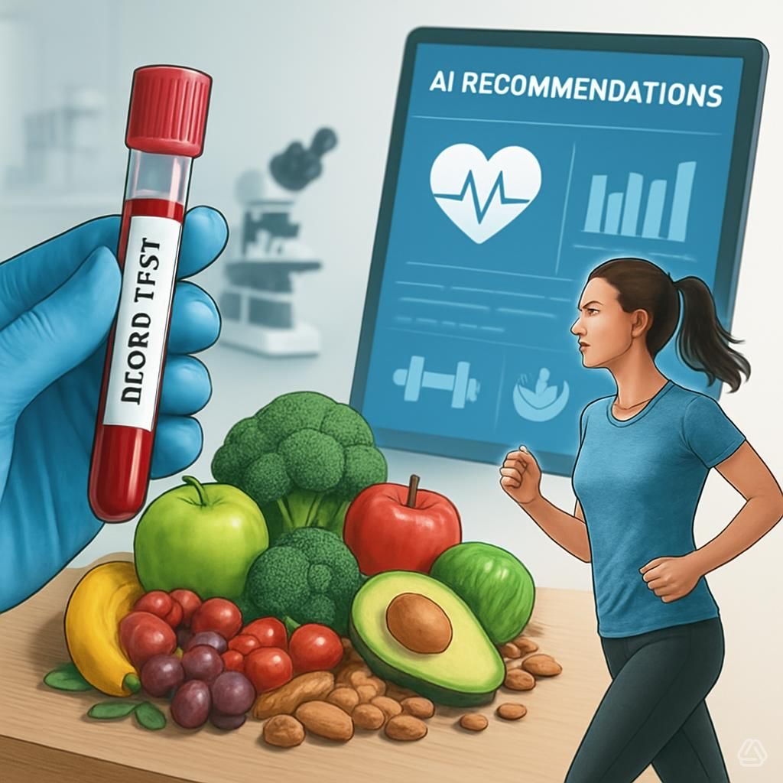

A- Blood testing
B- Nutrition and Hydration
C- Fitness data
Result by AI
D- Supplements
Results by Ai
E- consulting by using telemedicine
Results by Ai and Doktor

Individual longevity disgn health plan

